Master Functional Document

Application | NGERP - Centra
Service Bundle | Master Management
Service Request | Vendor

Description :

Vendor master is used to show list of partner’s who are vendors.

Workflow Process :

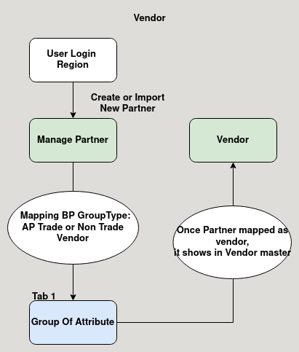

Business Rules :

- when partner is created in manage partner with the Business partner group type of AP Trade or Non Trade Vendor it shows in the vendor master.
- This master is not editable in both HQ and Region.
- When login HQ it shows list of vendors in all region.
- When login as Region it shows the vendor list for that region only.

